**Edwest Examination, 2015**

**Question/ Answer Booklet**

**HUMAN BIOLOGICAL SCIENCE**

**Stage 3**

Name ______________________

Class ______________________

Teacher Name ______________________

**Time allowed for this paper**

Reading time before commencing work: ten mins

Working time for paper three hours

**Materials required/ recommended for this paper**

To be provided by the supervisor

**This Question/ Answer Booklet**

**Multiple- choice Answer Sheet**

***To be provided by the candidate***

Standard items: pens, pencils, eraser, correction fluid, ruler, highlighters

Special items: non-programmable calculators satisfying the conditions set by the Curriculum Council for this course

**Important note to candidates**

No other items may be taken into the examination room. It is **your** responsibility to ensure that you do not have any unauthorised notes or other items of a non‑personal nature in the examination room. If you have any unauthorised material with you, hand it to the supervisor **before** reading any further.

**Structure of this paper**

|  |  |  |  |  |  |  |
| --- | --- | --- | --- | --- | --- | --- |
| **Section** | **Number of questions available** | **Number of questions to be answered** | **Suggested working time**  **(minutes)** | **Marks available** | **Percentage of exam** | **Student Score** |
| **Section One:**  **Multiple-choice** | 30 | 30 | 40 | 30 | 30 |  |
| **Section Two:**  **Short answer** | 12 | 12 | 90 | 100 | 50 |  |
| **Section Three:**  **Extended answer** | 3 | 2 | 50 | 40 | 20 |  |
|  | | | | | 100 |  |

**Instructions to candidates**

1. The rules for the conduct of Western Australian external examinations are detailed in the *Year 12 Information Handbook 2015.* Sitting this examination implies that you agree to abide by these rules.

2. Answer the questions according to the following instructions.

**Section One**: Answer all questions on the separate Multiple-choice Answer Sheet provided. For each question shade the box to indicate your answer. Use only a blue or black pen to shade the boxes. If you make a mistake, place a cross through that square, do not erase or use correction fluid, and shade your new answer. Marks will not be deducted for incorrect answers. No marks will be given if more than one answer is completed for any question.

**Sections Two and Three**: Write answers in this Question/Answer Booklet.

3. You must be careful to confine your responses to the specific questions asked and to follow any instructions that are specific to a particular question.

4. Spare pages are included at the end of this booklet. They can be used for planning your responses and/or as additional space if required to continue an answer.

* + Planning: If you use the spare pages for planning, indicate this clearly at the top of the page.
  + Continuing an answer: If you need to use the space to continue an answer, indicate in the original answer space where the answer is continued, i.e. give the page number. Fill in the number of the question(s) that you are continuing to answer at the top of the page.

**Section One: Multiple-choice 30% (30 Marks)**

This section has **30** questions. Answer **all** questions on the separate Multiple-choice Answer Sheet provided. For each question shade the box to indicate your answer. Use only a blue or black pen to shade the boxes. If you make a mistake, place a cross through that square, do not erase or use correction fluid, and shade your new answer. Marks will not be deducted for incorrect answers. No marks will be given if more than one answer is completed for any question.

Suggested working time for this section is 30 minutes.

1. The hormone insulin will decrease blood sugar concentration through a number of processes. Which of the following is not a function of insulin?

1. glycogenesis
2. lipolysis
3. gluconeogenesis
4. lipogenesis

2. Adrenaline is secreted by the

1. adrenal cortex.
2. hypothalamus.
3. anterior pituitary gland.
4. adrenal medulla.

3. The effect on the kidney of a high concentration of ADH in the blood is

1. increased tubule permeability and an increase in water reabsorption.
2. decreased tubule permeability and a decrease in water loss.
3. increased filtration rate and increased water loss.
4. decreased filtration rate and decreased urine production.

4. A person who is hyperventilating will often be given a paper bag to breathe into. The purpose of this is to

(a) decrease oxygen levels and increase the parasympathetic stimulation of the diaphragm.

(b) increase carbon dioxide levels and stimulate the diaphragm by motor neurones.

(c) increase carbon dioxide levels and increase sympathetic stimulation of the diaphragm.

(d) decrease carbon dioxide levels and stimulate the diaphragm by sensory neurones.

5. Several receptors are involved in the homeostatic control of blood pH. These include

1. aortic and carotid bodies and the medulla oblongata.
2. medulla oblongata, carotid artery and sino-atrial node.
3. medulla oblongata, hypothalamus and pituitary gland.
4. carotid artery, aorta and the sino-atrial node.

Questions 6 & 7 refer to the diagram below.

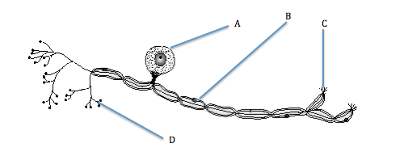

6. Identify the type of neuron pictured above

1. motor neuron
2. sensory neuron
3. connector neuron
4. Interneuron

7. Which part of the structure shown above increases the speed of nerve transmission?

1. A
2. B
3. C
4. D

8. Which of the following identifies the correct function of the hypothalamus?

1. links the nervous system and all endocrine glands
2. produces oxytocin which is released by the anterior pituitary gland
3. regulates the secretion of hormones by the anterior pituitary gland
4. controls all activities of the pituitary gland

9. A breastfed baby receives antibodies from it’s mother’s milk. This is an example of

1. artificial active immunity.
2. artificial passive immunity.
3. natural passive immunity.
4. natural active immunity.

10. A possible response to a non-self antigen entering the body could be

1. B-cells carrying out a cell mediated response.
2. T-cells engulfing a pathogen.
3. B-cells producing antibodies.
4. T-Cells destroyed by lymphocytes.

11. A type of vaccine which uses a fragment of an organism to initiate an immune response is referred to as

1. sub-unit vaccine.
2. toxoid vaccine.
3. living-attenuated micro-organisms.
4. dead micro-organisms.

12. Identify the type of joint pictured below

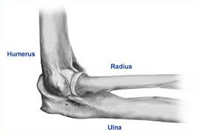

1. ball and socket joint
2. hinge joint
3. saddle joint
4. gliding joint

13. The general name for a movement that decreases the angle between bones in a joint is

1. adduction.
2. abduction.
3. flexion.
4. extension.

14. The somatic division of the nervous system carries nerve impulses to the

1. skeletal muscles.
2. heart and blood vessels.
3. muscles of the digestive system.
4. endocrine glands.

15. Efferent impulses are those that travel

1. towards the brain within sensory neurons.
2. away from the brain within motor neurons.
3. within the autonomic system only.
4. within the parasympathetic nervous system.

16. Which of the following degenerative conditions results from a deficiency in the neurotransmitter dopamine?

1. Alzheimer’s Disease
2. Multiple Sclerosis
3. Parkinson’s Disease
4. Motor Neuron Disease

17. Which of the following statements regarding the plasma membrane is false?

1. Phospholipid heads are hydrophobic
2. Phospholipids form a bilayer
3. Carrier proteins are involved in active transport across the membrane
4. Receptor proteins on the membrane bind to specific molecules

18. Melanocytes are skin cells that produce melanosomes. Melanosomes contain the pigment melanin. Which of the following statements regarding melanin is correct?

1. Melanin gives colour to human hair, eyes and skin
2. Melanin is consistently distributed across all humans
3. Ultra violet light has no effect on melanin production
4. Melanin production is an example of monogenic inheritance

19. Identify the neurotransmitter released at the neuromuscular junction.

1. dopamine
2. noradrenaline
3. acetylcholine
4. serotonin

20. If 10% of the bases in a molecule of DNA are adenine, what is the ratio of adenine to guanine in the same molecule?

1. 1:1
2. 1:2
3. 1:3
4. 1:4

21. Gene therapy for cystic fibrosis would be considered most successful in which of the following circumstances?

1. The mutated gene affects only some of the cells in the body.
2. Environmental factors are the primary cause of the disease.
3. More than one gene has caused the condition.
4. The condition is cause by a single gene mutation.

22. An experiment was carried out to estimate the concentration of urea present in urine samples.

The method involved adding tablets of the enzyme urease to the urine samples in a test tube and timing how long it takes for litmus paper to turn blue.

Which two factors would have to be kept the same throughout the investigation?

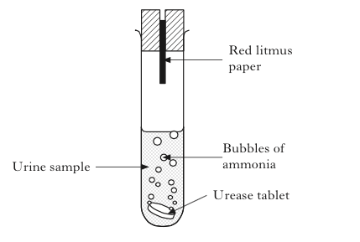

1. size of tablet and concentration of urea
2. concentration of urea and time
3. size of tablet and volume of urine
4. volume of urine and time

23. Over time the allele frequency within a gene pool fluctuates causing an increase or decrease in variety. This is of increased significance within small populations. This is known as

1. migration.
2. natural selection.
3. founder effect.
4. random genetic drift.

24. Human DNA polymerase is not used in PCR. Which of these statements identifies the correct reason for this?

1. It is not functional outside the human body.
2. It is expensive to make synthetic copies to use in multiple reactions.
3. It is difficult to isolate and extract from human cells.
4. It cannot withstand the high temperatures in the first step of PCR.

25. The image below was created by a biotechnology technique.

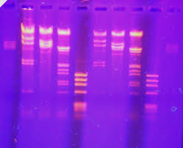

This technique is known as

1. DNA profling.
2. DNA fingerprinting.
3. gel electrophoresis.
4. polymerase chain reaction.

26. Which of the following would not be considered an epigenetic factor?

1. modification of the chromatin wrapped around the histone.
2. addition of a methyl group to the histone protein.
3. addition of an acetyl group to the histone protein.
4. a change in the order of the bases on the DNA molecule.

27. Scientists use comparative studies to provide evolutionary evidence that organisms could share a common ancestor. Which of the following comparative study methods would provide the most precise genetic evidence of a common ancestor?

1. Embryology
2. Vestigial organs
3. Non-functional DNA
4. Homologous structures

28. Carbon-14 dating is a method used to determine the age of some fossil specimens. This method is used to date

1. organic fossils more than 60, 000 years old.
2. inorganic fossils more than 60, 000 years old.
3. organic fossils less than 60, 000 years old.
4. inorganic fossils less than 60, 000 years old.

29. A fossilised skeleton was discovered in a semi-arboreal region of Africa. Paleoanthropologists determined that the skeleton is bipedal due to several distinguishing features. What features would you expect to be present in this skeleton?

1. narrow pelvis, s-shaped spine, protruding jaw
2. central foramen magnum, protruding jaw, short pelvis
3. s-shaped spine, long pelvis, central foramen magnum
4. broad pelvis, central foramen magnum, s-shaped spine

30. At the same archaeological site, several tools were found providing further evidence that the skeleton was *Homo erectus*. From the list below, which tools would most likely be associated with *Homo erectus*?

1. pebble tools
2. flaked hand axes
3. chisel cutter
4. bone tools

**End of Section One**

**Section Two: Short answer 50% (100 Marks)**

This section has **twelve** (**12)** questions. Answer **all** questions. Write your answers in the space provided.

Spare pages are included at the end of this booklet. They can be used for planning your responses and/or as additional space if required to continue an answer.

* Planning: If you use the spare pages for planning, indicate this clearly at the top of the page.
* Continuing an answer: If you need to use the space to continue an answer, indicate in the original answer space where the answer is continued, i.e. give the page number. Fill in the number of the question(s) that you are continuing to answer at the top of the page.

**Suggested working time for this section is 90 minutes.**

**Question 31 (11 marks)**

Refer to the table shown below.

|  |  |
| --- | --- |
| **Amino Acid** | **tRNA- anti-codon** |
| Histidine | CAU |
| Glutamic Acid | GAG |
| Aspartic Acid | GAU |
| Alanine | GCG |
| Stop codon | UAG |
| Tyrosine | UAU |
| Serine | UAU |
| Tryptophan | UGG |
| Leucine | UUA |

(a)Based on the information given in the table, complete the table below.

(2 marks)

|  |  |  |
| --- | --- | --- |
| Amino Acid | DNA Triplet | mRNA codon |
| Serine |  |  |

(b)Haemophiliacs cannot synthesis the protein Factor VIII and for many years, were dependent on injections made from human plasma. The risk of infection from HIV and hepatitis C was high.

The production of a synthetic Factor VIII has reduced this risk to Haemophiliacs.

The pharmaceutical production of Factor VIII involves recombinant DNA technology. Outline the required steps in the pharmaceutical production of Factor VIII.

(5 marks)

**______________________________________________________________________________________________________________________________________________________________________________________________________________________________________________________________________________________________________________________________________________________________________________**

(c)Complete the table below outlining the function of a promoter gene and a structural gene. (2 marks)

|  |  |
| --- | --- |
|  | **Function** |
| **Promoter Gene** |  |
| **Structural Gene** |  |

(d) Identify two factors that determine whether a gene is “switched on” or “switched off” (2 marks)

_____________________________________________________________

_____________________________________________________________

**Question 32 (8 marks)**

James and John are both in their mid 40s. James leads a reasonably healthy

lifestyle, has a well balanced diet and is physically active. John has developed poor

eating habits over the past 10 years and no longer takes part in regular exercise.

John is overweight and recently noticed that he is extremely thirsty all of the time.

(a) Identify the condition from which John may be suffering. (1 mark)

_____________________________________________________________

(b) James is having minor surgery and has been instructed to fast for 24 hours prior to surgery. Describe how James’s blood glucose concentration will remain stable during this time of fasting. (5 marks)

**______________________________________________________________________________________________________________________________________________________________________________________________________________________________________________________________________________________________________________________________________________________________________________**

(c) During a flight or fight response, the hormone cortisol may be secreted in order to ensure that the body has energy available for immediate use.

Describe the effects cortisol has on blood glucose. (2 marks)

**____________________________________________________________________________________________________________________________________________________________________________________________________________________________________________________**

**Question 33 (6 marks)**

(a) Complete the table below by identifying differences between the endocrine and nervous systems. (4 marks)

|  |  |  |
| --- | --- | --- |
|  | **Endocrine System** | **Nervous System** |
| Speed |  |  |
| Duration |  |  |

(b) Outline two differences between amine and steroid hormones. (2 marks)

1. ___________________________________________________________

___________________________________________________________

1. ___________________________________________________________

___________________________________________________________

**Question 34 (8 marks)**

Hydrogen peroxide is a harmful by-product of many metabolic processes and must be converted into other less harmful substances. Catalase breaks down hydrogen peroxide into water and oxygen gas. The rate of this reaction can be measured by adding several drops of detergent to a test tube containing hydrogen peroxide and catalase. A layer of foam will form in the test tube if oxygen gas is present.

A student investigating the affect of pH on catalase set up 7 tests tubes. Each test tube contained 20ml of hydrogen peroxide, 5 ml of catalase and 5 drops of detergent. She added a pH buffer solution to each test tube and recorded the results in the table below.

|  |  |
| --- | --- |
| **Buffer Solution**  **pH** | **Height of Foam**  **(mm)** |
| 1 | 0 |
| 3 | 2 |
| 5 | 65 |
| 7 | 102 |
| 8 | 72 |
| 9 | 42 |
| 11 | 9 |

(a) Identify the dependent variable in this investigation (1 mark)

_____________________________________________________________

(b) Identify the independent variable in this investigation (1 mark)

_____________________________________________________________

(c) Identify two possible control variables in this investigation (2 marks)

1___________________________________________________________

2 ___________________________________________________________

(d) Graph the data presented in the table on the previous page. (4 marks)

*(Additional graph paper can be found at the back of the question/ answer booklet)*

|  |  |  |  |  |  |  |  |  |  |  |  |  |  |  |
| --- | --- | --- | --- | --- | --- | --- | --- | --- | --- | --- | --- | --- | --- | --- |
|  |  |  |  |  |  |  |  |  |  |  |  |  |  |  |
|  |  |  |  |  |  |  |  |  |  |  |  |  |  |  |
|  |  |  |  |  |  |  |  |  |  |  |  |  |  |  |
|  |  |  |  |  |  |  |  |  |  |  |  |  |  |  |
|  |  |  |  |  |  |  |  |  |  |  |  |  |  |  |
|  |  |  |  |  |  |  |  |  |  |  |  |  |  |  |
|  |  |  |  |  |  |  |  |  |  |  |  |  |  |  |
|  |  |  |  |  |  |  |  |  |  |  |  |  |  |  |
|  |  |  |  |  |  |  |  |  |  |  |  |  |  |  |
|  |  |  |  |  |  |  |  |  |  |  |  |  |  |  |
|  |  |  |  |  |  |  |  |  |  |  |  |  |  |  |
|  |  |  |  |  |  |  |  |  |  |  |  |  |  |  |
|  |  |  |  |  |  |  |  |  |  |  |  |  |  |  |
|  |  |  |  |  |  |  |  |  |  |  |  |  |  |  |
|  |  |  |  |  |  |  |  |  |  |  |  |  |  |  |
|  |  |  |  |  |  |  |  |  |  |  |  |  |  |  |
|  |  |  |  |  |  |  |  |  |  |  |  |  |  |  |
|  |  |  |  |  |  |  |  |  |  |  |  |  |  |  |
|  |  |  |  |  |  |  |  |  |  |  |  |  |  |  |

**Question 35 (11 marks)**

Parts (a) and (b) of the question refer to the diagram below.

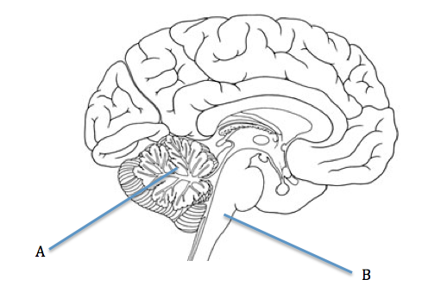

(a) Identify structure A ____________________________________________

(1 mark)

(b) Describe 2 functions of structure B (2 marks)

1 ___________________________________________________________

2 ___________________________________________________________

The diagram below illustrates a reflex arc.

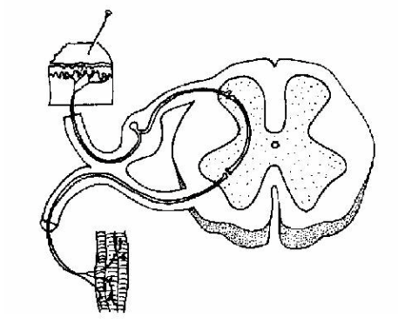

(c) Describe the sequence of events that would occur if a person stepped on a pin. (3 marks)

**_______________________________________________________________________________________________________________________________________________________________________________________**

(d) Explain why this could be considered a protective mechanism. (2 marks)

**_______________________________________________________________________________________________________________________________________________________________________________________**

Use the diagram below to answer the following question.

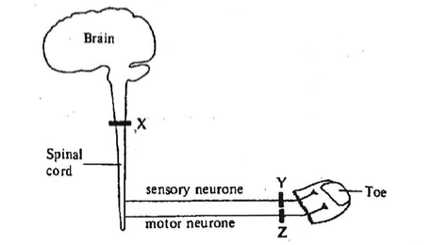

(e) A patient is having a local anaesthetic during a minor procedure on a toe. If the block is at point Y, explain the affect on the patient in terms of sensation and movement. (3 marks)

**_______________________________________________________________________________________________________________________________________________________________________________________**

**Question 36 (9 marks)**

The graph below represents an action potential.

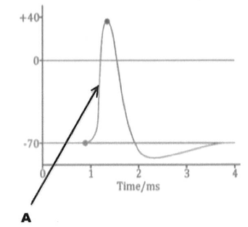

(a) Outline the events occurring at the point labelled A. (5 marks)

**______________________________________________________________________________________________________________________________________________________________________________________________________________________________________________________________________________________________________________________________________________________________________________**

(b) Describe the difference between a nerve impulse travelling along a myelinated neuron compared to a nerve impulse travelling along a non-myelinated neuron. (4 marks)

**____________________________________________________________________________________________________________________________________________________________________________________________________________________________________________________**

**Question 37 (5 marks)**

This question refers to the diagram below.

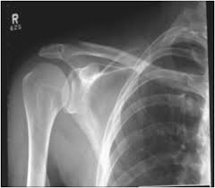

(a) The shoulder joint can be described as freely moveable. Identify this type of joint and list two structures that limit movement at this joint. (3 marks)

**____________________________________________________________________________________________________________________________________________________________________________________________________________________________________________________**

(b) Explain why cartilage takes longer to heal than bone. (2 marks)

**_______________________________________________________________________________________________________________________________________________________________________________________**

**Question 38 (8 marks)**

The graph below shows how female bone density changes with age.

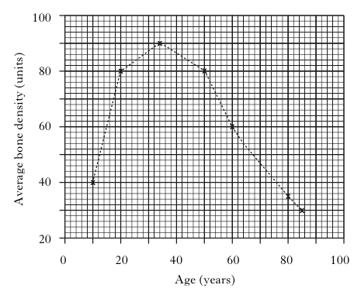

When bone density falls to 60% of its maximum, there is an increased chance of

bone breakage.

(a) Identify the age on this graph where bone density falls to 60% of its maximum. (1 mark)

__________________________

(b) Name the condition that occurs when bones lose their strength and density.

(1 mark)

____________________________________________________

(c) How can this condition be treated? (2 marks)

_______________________________________________________________________________________________________________________________________________________________________________________

(d) The following question refers to the diagram below

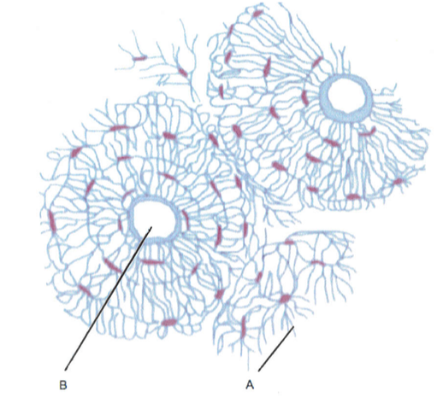

Complete the table below identifying the structures and functions microscopic bone. (4 marks)

|  |  |  |
| --- | --- | --- |
|  | **Structure** | **Function** |
| **A** |  |  |
| **B** |  |  |

**Question 39 (7 marks)**

Chicken pox is a common illness that most children are exposed to several times throughout early childhood. Chicken pox is highly contagious, however it is uncommon for a child to develop chicken pox more than once during childhood.

(a) Explain how the body responds to the first exposure to chicken-pox compared to subsequent exposures. (6 marks)

___________________________________________________________________________________________________________________________________________________________________________________________________________________________________________________________________________________________________________________________________________________________________________________________________________________________________________

(b) Identify the type of immunity brought about through this exposure. (1 mark)

_____________________________________________________________

**Question 40 (12 marks)**

Polymerase Chain Reaction is an example of a biotechnological technique.

(a) Outline the process of Polymerase Chain Reaction (6 marks)

___________________________________________________________________________________________________________________________________________________________________________________________________________________________________________________________________________________________________________________________________________________________________________________________________________________________________________

(b) Identify two uses of PCR (2 marks)

1 ____________________________________________________________

2 ____________________________________________________________

(c) Complete the table below comparing DNA sequencing and DNA profiling.

(4 marks)

|  |  |  |
| --- | --- | --- |
| Biotechnological Technique | Function | Use |
| DNA Sequencing |  |  |
| DNA Profiling |  |  |

**Question 41 (7 marks)**

(a) Identify two adaptations to bipedalism below the waist. Describe the of the adaptations provided.

(4 marks)

|  |  |
| --- | --- |
| **Adaptation** | **Advantage** |
|  |  |
|  |  |

(b) Define the term ‘optical-olfactory shift’. (3 marks)

_______________________________________________________________________________________________________________________________________________________________________________________

**Question 42 (8 marks)**

(a) Complete the following table on dating techniques. State whether the technique is relative or absolute and give a brief description of each.

(6 marks)

|  |  |  |
| --- | --- | --- |
| **Dating Technique** | **Relative or Absolute** | **Description** |
| **Carbon-14** |  |  |
| **Fluorine Dating** |  |  |

(b) Mitochondrial DNA can be used as evidence for evolution. Explain why this data can only be used to show evolutionary relationships of maternal ancestry. (2 marks)

____________________________________________________________________________________________________________________________________________________________________________________________________________________________________________________

**End of Section Two**

**Section Three: Extended answer 20% (40 Marks)**

This section contains **three (3)** questions. You must answer **two (2)** questions. Write your answers in the space provided.

Spare pages are included at the end of this booklet. They can be used for planning your responses and/or as additional space if required to continue an answer.

* Planning: If you use the spare pages for planning, indicate this clearly at the top of the page.
* Continuing an answer: If you need to use the space to continue an answer, indicate in the original answer space where the answer is continued, i.e. give the page number. Fill in the number of the question(s) that you are continuing to answer at the top of the page.

Responses could include clearly labelled diagrams with explanatory notes; lists of points with linking sentences; clearly labelled tables and graphs; and annotated flow diagrams with introductory notes.

Suggested working time: 50 minutes.

Answer any **two (2)** questions from Questions 43 to 45.

**Question 43 (20 marks)**

(a) Give an account of how the body maintains a constant internal temperature in cold conditions. Use the headings of physiological and behavioural responses. (12 marks)

(b) Outline the process through which proteins are produced by the body. (8 marks)

**Question 44 (20 marks)**

(a) The interaction of muscles, bones and the nervous system are crucial in sports such as golf, baseball and cricket. Describe the interaction of the musculoskeletal system and the nervous system that allow controlled and precise movement in these sports. (13 marks)

(b) Outline the process by which the contraction of muscle is thought to occur. (7 marks)

**Question 45 (20 marks)**

(a) The principles of evolution work through natural selection to generate a multitude of species. Give an account of the importance of isolating mechanisms, mutations and natural selection in the process of speciation. (10 marks)

(b) Beginning with Australopithecus and ending with *Homo erectus*, provide an account of the evolutionary trends that have occurred under the following headings:

(i) tools. (5 marks)

(ii) cultural trends. (5 marks)

**End of Questions**

_____________________________________________________________________________________________________________________________________________________________________________________________________________________________________________________________________________________________________________________________________________________________________________________________________________________________________________________________________________________

_____________________________________________________________________________________________________________________________________________________________________________________________________________________________________________________________________________________________________________________________________________________________________________________________________________________________________________________________________________________

_____________________________________________________________________________________________________________________________________________________________________________________________________________________________________________________________________________________________________________________________________________________________________________________________________________________________________________________________________________________

_______________________________________________________________________________________________________________________________________________________________________________________________________________________________________________________________________________________________________________________________________________

_____________________________________________________________________________________________________________________________________________________________________________________________________________________________________________________________________________________________________________________________________________________________________________________________________________________________________________________________________________________

_____________________________________________________________________________________________________________________________________________________________________________________________________________________________________________________________________________________________________________________________________________________________________________________________________________________________________________________________________________________

_____________________________________________________________________________________________________________________________________________________________________________________________________________________________________________________________________________________________________________________________________________________________________________________________________________________________________________________________________________________

_______________________________________________________________________________________________________________________________________________________________________________________________________________________________________________________________________________________________________________________________________________

_____________________________________________________________________________________________________________________________________________________________________________________________________________________________________________________________________________________________________________________________________________________________________________________________________________________________________________________________________________________

_____________________________________________________________________________________________________________________________________________________________________________________________________________________________________________________________________________________________________________________________________________________________________________________________________________________________________________________________________________________

_____________________________________________________________________________________________________________________________________________________________________________________________________________________________________________________________________________________________________________________________________________________________________________________________________________________________________________________________________________________

_______________________________________________________________________________________________________________________________________________________________________________________________________________________________________________________________________________________________________________________________________________

_____________________________________________________________________________________________________________________________________________________________________________________________________________________________________________________________________________________________________________________________________________________________________________________________________________________________________________________________________________________

_____________________________________________________________________________________________________________________________________________________________________________________________________________________________________________________________________________________________________________________________________________________________________________________________________________________________________________________________________________________

_____________________________________________________________________________________________________________________________________________________________________________________________________________________________________________________________________________________________________________________________________________________________________________________________________________________________________________________________________________________

_______________________________________________________________________________________________________________________________________________________________________________________________________________________________________________________________________________________________________________________________________________

_____________________________________________________________________________________________________________________________________________________________________________________________________________________________________________________________________________________________________________________________________________________________________________________________________________________________________________________________________________________

_____________________________________________________________________________________________________________________________________________________________________________________________________________________________________________________________________________________________________________________________________________________________________________________________________________________________________________________________________________________

_____________________________________________________________________________________________________________________________________________________________________________________________________________________________________________________________________________________________________________________________________________________________________________________________________________________________________________________________________________________

_______________________________________________________________________________________________________________________________________________________________________________________________________________________________________________________________________________________________________________________________________________

_____________________________________________________________________________________________________________________________________________________________________________________________________________________________________________________________________________________________________________________________________________________________________________________________________________________________________________________________________________________

_____________________________________________________________________________________________________________________________________________________________________________________________________________________________________________________________________________________________________________________________________________________________________________________________________________________________________________________________________________________

_____________________________________________________________________________________________________________________________________________________________________________________________________________________________________________________________________________________________________________________________________________________________________________________________________________________________________________________________________________________

_______________________________________________________________________________________________________________________________________________________________________________________________________________________________________________________________________________________________________________________________________________

_____________________________________________________________________________________________________________________________________________________________________________________________________________________________________________________________________________________________________________________________________________________________________________________________________________________________________________________________________________________

_____________________________________________________________________________________________________________________________________________________________________________________________________________________________________________________________________________________________________________________________________________________________________________________________________________________________________________________________________________________

_____________________________________________________________________________________________________________________________________________________________________________________________________________________________________________________________________________________________________________________________________________________________________________________________________________________________________________________________________________________

_______________________________________________________________________________________________________________________________________________________________________________________________________________________________________________________________________________________________________________________________________________

_____________________________________________________________________________________________________________________________________________________________________________________________________________________________________________________________________________________________________________________________________________________________________________________________________________________________________________________________________________________

_____________________________________________________________________________________________________________________________________________________________________________________________________________________________________________________________________________________________________________________________________________________________________________________________________________________________________________________________________________________

_____________________________________________________________________________________________________________________________________________________________________________________________________________________________________________________________________________________________________________________________________________________________________________________________________________________________________________________________________________________

_______________________________________________________________________________________________________________________________________________________________________________________________________________________________________________________________________________________________________________________________________________

_____________________________________________________________________________________________________________________________________________________________________________________________________________________________________________________________________________________________________________________________________________________________________________________________________________________________________________________________________________________

__________________________________________________________________________________________________________________________________________________________________________________________________________________________________________________________________________________________________________________________________________________________________________________________________________________

Use the grid to answer question 34(d) if you have cancelled your first attempt.



Image from question 6 comes from <http://gallery4share.com/s/sensory-neuron-diagram-labeled.html>

Image from question 12 comes from <https://www.orthoneuro.com/patient-education/tools/elbow>

Image from 1uestion 25 comes from <http://biology.clc.uc.edu/fankhauser/Labs/Genetics/DNA_Electrophoresis/DNA_Electrophoresis.htm>

Image from question 37b comes from <https://www.ceessentials.net/article31.html>

Image from question 38 (d) comes from <http://blog.drwile.com/?p=10065>